**1.Sub Type/Inheritance Mismatch:-**

We have subtype or inheritance concept in Object oriented Model. But same concept is not in Relational model.

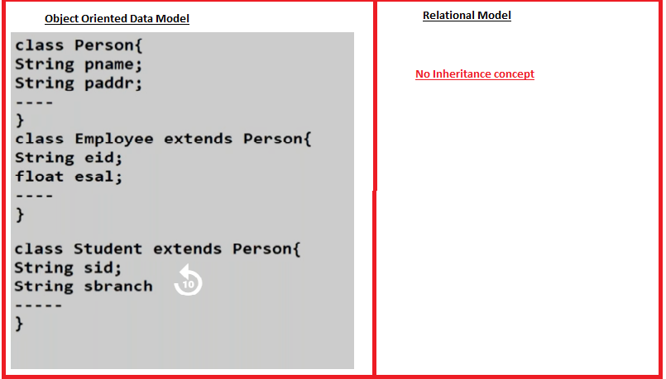

Every ORM implementation (Hibernate/Open JPA) gave 3 types of solutions to sub type mismatch.

1. Table per class hierarchy.
2. Table per sub class.
3. Table per concrete class.
4. **Table per class Hierarchy:-**

We create separate relations for parent class and for subclasses of hierarchy in Relation Data model using foreign key and primary key relation ship.

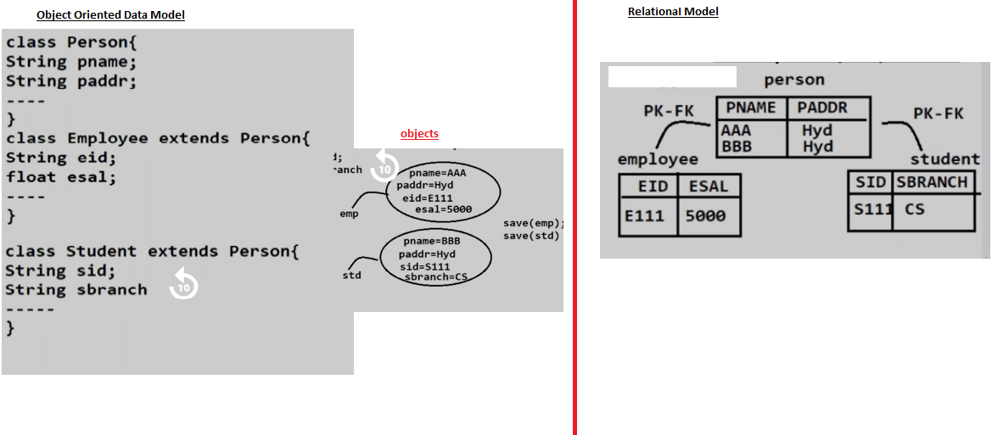

**B.Table per SubClass**:- we create separate relation in Relational Data model for every sub class of hierarchy. This relation has all properties of super class and sub class as columns.

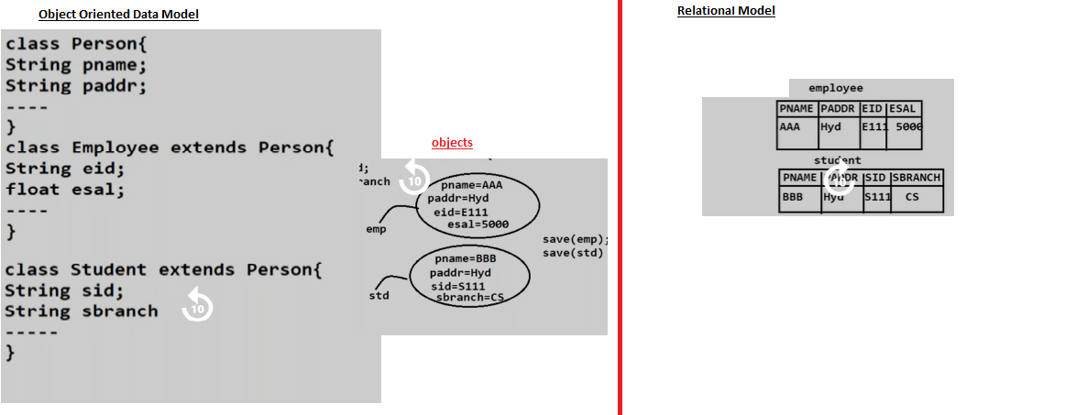

**C.Table per Concrete Class:-**  we create a single relation for parent and for all subclasses of hierarchy in relational data model. This class have all properties of parent and subclasses as columns.

